Prototype Agentic Healthcare Assistant with WhatsApp Interface and API Integrations


[2025-2026]

Project Phase-I Report

Bachelor of Technology (INFORMATION TECHNOLOGY)

Supervised by: Vivek Menon
Submitted by: Srijan Singh

Professor 0801IT221126
Information Technology Information Technology

Sudhanshu Chouksay 0801IT221127
Information Technology
Mentor’s Signature

Satyesh Uikey 0801IT221117
Information Technology

DEPARTMENT OF INFORMATION TECHNOLOGY
SHRI GOVINDRAM SEKSARIA INSTITUTE OF TECHNOLOGY AND SCIENCE, INDORE(M.P.)

SHRI GOVINDRAM SEKSARIA INSTITUTE OF TECHNOLOGY AND SCIENCE, INDORE (M.P.)
A Govt. Aided Autonomous Institute, Affiliated to RGPV, Bhopal
DEPARTMENT OF INFORMATION TECHNOLOGY]



CERTIFICATE

This is to certify that the Dissertation Phase-I titled “Prototype Agentic Healthcare Assistant with WhatsApp Interface and API Integrations”, submitted by Srijan Singh, Sudhanshu Chouksay, and Satyesh Uikey, has been accepted in partial fulfillment of the requirements for the degree under the Department of Information Technology, Rajiv Gandhi Proudyogiki Vishwavidyalaya (RGPV), Bhopal, during the academic session 2025–2026.

Internal Examiner External Examiner
Date: Date:

ABSTRACT
This project presents the design and development of an AI-driven healthcare assistance system delivered through a WhatsApp-based conversational chatbot. The system integrates a Python backend, Large Language Models (LLMs), OCR pipelines, and third-party APIs to provide symptom-based preliminary guidance, prescription and lab report analysis, medicine ordering, and medication reminders, offering users accessible and reliable first-level healthcare support. By leveraging OpenRouter-based LLM integration, the chatbot can infer potential medical conditions from symptoms, summarize prescriptions, analyze blood reports, and guide users toward appropriate next steps without providing diagnostic claims, thereby aligning with ethical and legal requirements in healthcare technology .
A multi-stage OCR and data-processing pipeline—featuring image pre-processing, advanced recognition models, and RegEx-driven extraction—enables accurate interpretation of complex medical documents such as handwritten prescriptions and semi-structured lab reports. Extracted data is stored in a secure, normalized PostgreSQL schema designed to ensure integrity, traceability, and compliance with India’s Digital Personal Data Protection (DPDP) Act, 2023, which mandates informed consent, data minimization, and robust security safeguards for handling sensitive health data .

The conversational interface utilizes WhatsApp for real-time interaction, with message handling and proactive reminder scheduling implemented through Twilio APIs. Cloud deployment via PaaS platforms ensures scalability, simplified DevOps management, and reliable service availability. The system also incorporates medical disclaimers, risk-mitigation strategies, and transparency mechanisms to address critical concerns related to AI hallucinations, user trust, and legal liability in healthcare applications .

Overall, this project demonstrates a complete, research-driven, end-to-end healthcare assistance ecosystem that combines AI reasoning, document intelligence, secure data management, and user-centered conversational design. It showcases how modern AI technologies can be responsibly integrated to enhance healthcare accessibility, reduce clinical burden, and support informed patient decision-making—while acknowledging the regulatory and ethical boundaries essential in real-world medical applications.

Table of Contents
Certificate 2
Abstract 3
List of Figures 6
1 INTRODUCTION 7

1.1 Overview :- . . . . . . . . . . . . . . . . . . . . . . . . . . . . . . . . . . | 7
1.2 Objectives :-. . . . . . . . . . . . . . . . . . . . . . . . . . . . . . . . . | 8
1.3 Problem statement :- . . . . . . . . . . . . . . . . . . . . . . . . . . . . . | 9
2 LITERATURE REVIEW | 10
3 SYSTEM DESIGN | 12
3.1 EXISTING SYSTEM .. . . . . . . . . . . . . . . . . . . . . . . . . . . . | 11
3.2 PROPOSED SYSTEM . . . . . . . . . . . . . . . . . . . . . . . . . . . . | 11
3.3 Modules…………………………………………………... | 13
3.4 System Analysis . . . . . . . . . . . . . . . . . . . . . . . . . . . . . . . | 13
3.4.1 Use case Diagram . . . . . . . . . . . . . . . . . . . . . . . . . . . . | 14
3.4.2 Class Diagram . . . . . . . . . . . . . . . . . . . . . . . . . . . 16
3.4.4 Activity Diagram. . . . . . . . . . . . . . . . . . . . . . . . . . . 18
3.4.3 Sequence Diagram . . . . . . . . . . . . . . . . . . . . . . . . . . . 20
3.5 Languages Used. . . . . . . . . . . . . . . . . . . . . . . . . . . . . . . 22

- Conclusion 23
  - Conclusion 23
REFERENCES 24

LIST OF FIGURES
Fig. No. Title Page No.
  - Use case Diagram 15
  - Class Diagram 17
  - Activity Diagram 19
  - Sequence Diagram 21

Chapter 1

Introduction:

1.1 Overview :

The rapid expansion of digital healthcare has created a growing demand for accessible, intelligent, and user-friendly medical assistance tools. Many individuals struggle to interpret symptoms accurately, access trustworthy medical information, or understand prescriptions and lab reports. To address these challenges, this project introduces an AI- driven healthcare system deployed through a WhatsApp chatbot interface, making healthcare guidance easily available on a platform widely used across India.

The system integrates Large Language Models (LLMs) for symptom interpretation and prescription inference, OCR pipelines for analyzing medical documents, and API integrations for medicine ordering and reminder notifications. Through a Python backend, OpenRouter-based AI services, and secure PostgreSQL data storage, the chatbot provides users with a seamless experience for preliminary medical guidance, report summarization, medication management, and health record organization .

Designed with legal and ethical safeguards—including DPDP Act– compliant consent flows, disclaimers, and risk-mitigation strategies—the system ensures responsible use of AI while improving accessibility, efficiency, and the overall digital healthcare experience.

Objective :-

The primary objectives of this project are:

Functional Objectives

- Develop an AI-powered healthcare chatbot that operates through WhatsApp, enabling real-time conversation using natural language.

- Implement symptom analysis and medical inference using LLMs to provide safe, preliminary health guidance based on user inputs .

- Build an OCR-based document analysis pipeline capable of extracting and summarizing information from prescriptions and lab reports, including handwritten and semi-structured documents.

- Enable medicine ordering and tracking through integration with third-party APIs such as Tata 1mg for inventory checks, order creation, and status updates.

- Provide medication reminders via WhatsApp messaging templates while considering platform limitations and compliance requirements.

- Design a secure relational database (PostgreSQL) to store user profiles, medical information, reports, and chat history.

- Ensure privacy and legal compliance, incorporating DPDP Act guidelines, informed consent, minimal data retention, and mandatory health disclaimers.

Technical Objectives

- Deploy the backend using cloud/PaaS infrastructure for scalability and reliability.

- Optimize AI interaction using prompt engineering, smart routing, and fallback mechanisms via OpenRouter.

- Implement effective error handling, caching, and asynchronous tasks for improved performance and lower latency.

- Build a modular and extensible architecture supporting future features such as telemedicine integration or advanced diagnostics.

Problem Statement
Despite significant advancements in digital healthcare, users still face major barriers in accessing reliable and personalized medical assistance. Most available platforms provide generic information, do not support conversation- based interaction, and lack the intelligence required to interpret user symptoms, prescriptions, or lab reports. Additionally, healthcare infrastructures remain overburdened with non-critical queries that could be handled through automated preliminary assistance.

Key problems identified:

User-Centric Challenges

Difficulty in identifying whether symptoms require medical attention.

Lack of trustworthy, easy-to-understand medical information tailored to individual users.

Inability to interpret prescriptions, handwritten notes, or diagnostic reports.

No unified system that can provide advice, analysis, reminders, and medicine ordering in one place.

Technological Gaps

Existing chatbots are often rule-based, inaccurate, and unable to handle complex medical queries or document interpretation.

OCR tools struggle with noisy, handwritten, or non-standard medical documents, resulting in unreliable outputs .

Lack of integrated AI pipelines combining LLM reasoning, OCR extraction, and structured data analysis.

  - Compliance and Trust Issues

Users hesitate to trust AI-driven healthcare tools due to misinformation risks, limited transparency, and unclear boundaries between guidance and diagnosis .

Most systems fail to follow data protection mandates such as explicit consent, purpose limitation, and data minimization outlined in the DPDP Act, 2023.

Chapter 2

Literature Review:

Artificial Intelligence (AI) has become a transformative force in the healthcare domain, especially through conversational agents and automated preliminary diagnosis systems. As digital healthcare tools gain traction worldwide, researchers have increasingly explored how chatbots, NLP models, and multimodal AI can support early symptom assessment, patient education, and clinical decision-making. However, despite notable technological advancements, existing systems often fall short in accuracy, accessibility, multilingual support, document interpretation, and regulatory compliance. This literature review examines the evolution of healthcare chatbots, advances in medical NLP, OCR-based medical data extraction, conversational platforms, and the legal–ethical landscape to contextualize the need for the proposed AI-driven WhatsApp healthcare system.

  - Evolution of Medical Chatbots

Early chatbot systems in healthcare relied heavily on rule-based architectures that used keyword matching and decision trees to respond to user queries. While these systems provided basic informational support, their inability to understand natural language context limited their medical relevance and accuracy. More advanced tools such as Ada Health and WebMD’s Symptom Checker improved symptom assessment by using structured medical datasets and probabilistic reasoning. However, they are primarily text-only, lack multimodal interaction, and struggle to personalize responses for diverse populations.

Recent developments introduced domain-specific medical NLP models like BioBERT, ClinicalBERT, MedAlpaca, and PubMedBERT, which demonstrate substantially higher accuracy in clinical terminology understanding, entity extraction, and symptom classification. Yet, most commercial or public-facing medical chatbots still depend on general-purpose NLP models due to challenges in deploying specialized models at scale and the absence of unified AI pipelines in consumer platforms.

  - AI and LLMs for Symptom Interpretation

Large Language Models (LLMs) have redefined the capabilities of healthcare assistants by enabling deeper contextual understanding, reasoning, and medical inference. Through platforms such as OpenRouter, developers can access multiple high-performing models like Llama variants, supported by unified APIs, fallback routing, and consolidated billing. Studies emphasize that LLM performance improves significantly with few-shot prompting, chain-of-thought reasoning, structured instructions, and domain examples—all of which reduce hallucination and enhance the reliability of medical outputs .

However, LLMs pose risks when used in clinical settings. Literature documents several cases where AI-generated medical advice led to misinformation or delayed diagnosis. These concerns underscore the necessity of incorporating strict disclaimers, safety filters, and escalation mechanisms in any healthcare chatbot design. The project acknowledges these risks by limiting outputs to informational guidance rather than diagnostic conclusions.
  - OCR and Medical Document Analysis

Automated extraction of information from medical documents is one of the most challenging tasks in healthcare AI. Prescriptions often contain illegible handwriting, while lab reports feature mixed structures, tables, and irregular layouts. Research consistently shows that traditional OCR tools like Tesseract achieve only moderate accuracy (70–80%) in such scenarios and struggle with low-quality scans, handwritten notes, and medical abbreviations.

More advanced engines, such as EasyOCR, exhibit higher robustness when dealing with real-world medical documents, making them more suitable for student or prototype-level projects. Enterprise tools like Amazon Textract demonstrate industry-leading performance with features such as table recognition and key–value extraction, but their usage involves operational costs. The literature also emphasizes the importance of post-processing with Regular Expressions (RegEx) to extract structured fields (e.g., dosage, test values), while LLMs are recommended for contextual summarization when OCR outputs are incomplete or noisy

  - Conversational Interfaces and Messaging Platforms

Healthcare AI research shows a growing shift toward deploying chatbots on widely adopted communication platforms like WhatsApp. Unlike standalone mobile apps or web portals, WhatsApp provides a familiar interface, ease of use, and multilingual capabilities, significantly reducing barriers to adoption. Using APIs such as Twilio, developers can implement message-handling webhooks, conversational flows, and push notifications for medicine reminders.
However, limitations like daily message caps, template approval requirements, and customer-service time windows must be considered in the system’s design, as highlighted in the deep-dive research

  - Data Protection, Ethics, and User Trust

Handling health information requires compliance with strict legal and ethical frameworks. While global regulations like HIPAA (USA) and GDPR (EU) define standards, India’s Digital Personal Data Protection (DPDP) Act, 2023 sets explicit requirements for lawful processing, informed consent, data minimization, retention limits, and user rights. Studies emphasize that healthcare chatbots must provide transparent consent flows, avoid unauthorized data use, and maintain high security standards such as encryption and role-based access controls.

Ethically, AI models carry risks of bias, misinformation, and loss of trust, particularly in healthcare where accuracy is critical. Research shows that a majority of users remain skeptical about AI-generated medical guidance due to concerns over reliability and safety. Therefore, modern AI systems must employ disclaimers, human-in-the-loop safeguards, and clear communication about AI limitations to prevent misinterpretation and misuse

Chapter 3

System Design:

EXISTING SYSTEM

    - Most existing healthcare chatbots are rule-based and text-only, offering limited accuracy and no contextual understanding.

    - They do not support multimodal inputs like voice messages or medical document images (prescriptions, lab reports).

    - Traditional OCR tools used in current systems struggle with handwritten or complex medical documents, reducing reliability.

    - Existing platforms provide fragmented features (symptom checkers, medicine ordering, reminders) instead of an integrated solution.

    - Many systems lack proper data security, consent flows, and disclaimers, reducing user trust and violating modern data protection standards.

Proposed System:-

    - Introduces an AI-driven WhatsApp chatbot that supports text, voice, and image-based healthcare interactions.

    - Utilizes LLMs via OpenRouter for symptom analysis, medical summarization, and safe, structured responses.

    - Implements an OCR + RegEx + LLM pipeline for accurate extraction and interpretation of prescriptions and lab reports.

    - Integrates Tata 1mg APIs for real-time medicine ordering and delivery tracking, with WhatsApp reminder scheduling.

    - Ensures secure, compliant data handling through PostgreSQL storage, encrypted media (S3), and DPDP Act–aligned consent.

  - MODULES

    - WhatsApp Interface Module: Handles user messages (text/voice/image) through Twilio or Meta APIs.

    - AI/LLM Module: Processes symptoms, generates medical guidance, and validates OCR results.

    - OCR Processing Module: Performs image cleanup, text extraction, and structured field detection using EasyOCR + RegEx.

    - Order & Reminder Module: Manages medicine ordering, tracking, and WhatsApp reminder notifications.

    - Database & Security Module: Stores user data, prescriptions, chat history, and enforces security, encryption, and consent policies

  - SYSTEM ANALYSIS

    - System workflow supports end-to-end healthcare assistance: symptom input → AI inference → document analysis → order/reminder functions.

    - Asynchronous backend processing ensures low latency for WhatsApp interactions and efficient OCR/LLM operations.

    - PostgreSQL schema provides a single source of truth for user, prescription, and lab-report data, improving reliability.

    - Security controls (encryption, role-based access, consent logs) ensure compliance with DPDP Act and safe medical usage.

    - Risk factors like OCR errors and AI hallucinations are mitigated with prompt engineering, validation layers, and clear disclaimers.

Use Case Diagram

The Use Case Diagram models the functional requirements of the AI Healthcare & Insurance Assistant and illustrates how the primary actors — User and Admin
— interact with the system. The system boundary encapsulates the assistant’s services (symptom/insurance Q&A, document handling, medicine ordering, reminders and administrative functions). The goal of the diagram is to show the main user-facing capabilities and the support functions required to deliver them.

Actors

User: The primary actor who interacts with the assistant via WhatsApp (or other messaging channel) to request medical or insurance information, upload documents, order medicines, view reports, and set medication reminders.

Admin: The system administrator who manages symptom/test mappings, reviews system logs, and supervises OCR/model performance and order flows.

Primary Use Cases

Ask Medical Question → Receive AI Response: The user submits symptoms or a medical query and receives an AI-generated, non-diagnostic response that includes suggested next steps or recommended tests.

Ask Insurance Question → Receive AI Response: The user asks about insurance coverage or claims; the assistant provides information or guidance drawn from configured policies.

Upload Document → OCR Extraction: The user uploads prescriptions or lab reports; the document intelligence pipeline performs OCR, extracts structured fields, and stores both raw and parsed data.

Order Medicines: From a prescription or manual request, the user initiates a medicine order; the system communicates with third-party pharmacy APIs to check inventory and create orders.

Set Reminders / View Reports: The user schedules medication reminders or views past reports and conversation history stored in the database.

Manage System (Admin): The admin updates knowledge bases, reviews flagged AI outputs, and monitors system health and external integrations.

Relationships and Notes

The Receive AI Response use case is associated with both Ask Medical Question and Ask Insurance Question, representing the shared AI reply functionality.

Upload Document links to OCR Extraction to emphasize that document uploads trigger the OCR pipeline and downstream normalization by the AI.

Admin actions (Manage System) are linked to monitoring and to the OCR/AI processes to show that administrators can tune, correct, or override automated outputs.

Safety and compliance behaviors (disclaimers, human escalation for high-risk queries) are implicit system constraints applied to AI responses and order/reminder flows.
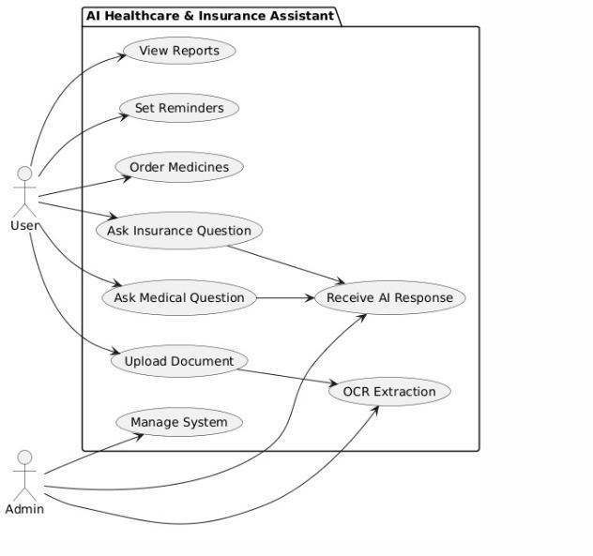

3.Class Diagram

The class diagram represents the structural design of the AI Healthcare Assistant, showing the core system entities and how they interact to process user queries, documents, and service requests.

Main Entities

User
Stores essential user information such as ID, name, and phone number. A user can have multiple chatbot interaction sessions.

Session
Tracks each interaction session with timestamps. Each session belongs to a single user and maintains context between messages.

Document
Represents uploaded prescriptions or reports. Each document stores metadata such as file type, path, and upload time, and is passed through the OCR pipeline.

Service Components

OCRService
Extracts text from uploaded medical documents using a configured OCR engine. Provides raw text output for further analysis.

Retriever
Uses vector embeddings to fetch relevant contextual chunks that help the LLM generate accurate responses. Supports top-k retrieval for efficiency.

LLMService
The core intelligence module. It classifies the user’s intent, generates medical or informational responses, and uses retrieved context plus OCR data to improve accuracy.

External Integrations

TwilioAPI
Sends chatbot responses back to the user on WhatsApp through Twilio’s messaging API.

PharmacyAPI
Communicates with external pharmacy services to place medicine orders, check inventory, and process prescription-based requests.

Relationships

A User can have multiple Sessions, and each session may involve multiple document uploads.

Document objects are processed by OCRService, whose extracted data is sent to Retriever and then used by LLMService for generating responses.

The LLMService integrates with TwilioAPI to deliver outputs and with PharmacyAPI to fulfill medicine orders.

Class Diagram
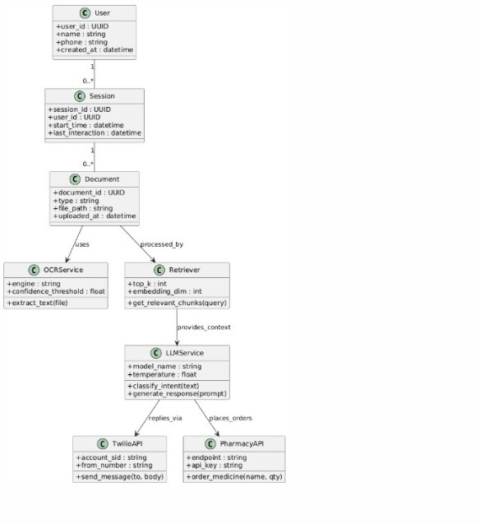

Activity Diagram

The activity diagram models the core run-time flow for a single user interaction with the AI Healthcare Assistant. It shows how the system receives a message, decides whether the input is a document or text, processes OCR when required, uses the extracted/typed text as context for an LLM, and returns a reply — including the decision points, sequential tasks and the terminal states.

Key flow (step-by-step):

Start — user sends a message (text, voice note or image).

Receive message — webhook controller validates the incoming payload and stores basic meta (timestamp, session id).

Detect intent / classify input — an intent classifier determines whether the user asked a medical/insurance question, requested ordering/reminder actions, or uploaded a document.

Decision: Is the input a document?

Yes (document/image): route to the OCR pipeline.

Perform OCR — image pre-processing (denoise/deskew/contrast) and OCR extraction.

Extract & post-process — RegEx and normalization to pull structured fields (drug names, dosages, lab values).
No (text/voice): convert voice to text if needed (STT), then use the user text directly.
Merge context — combine session history, user profile, and any OCR output to create the LLM prompt.
Generate response (LLM) — call the LLM with a constrained prompt and request a structured output; apply safety filters and add mandatory disclaimers.
Post-response actions — if the response contains an order request, forward to PharmacyAPI; if reminders are required, schedule via the job queue.
Send reply — deliver the formatted response back to the user via Twilio/WhatsApp. End — record the interaction outcome (logs, DB write, telemetry).

Important control & non-functional notes:

Decision nodes: intent detection and document-vs-text branching are explicit decision points that determine the processing path.

Asynchronous tasks: OCR, STT and long LLM calls should run as background tasks (workers) so the webhook can acknowledge receipt quickly.

Error handling: OCR failures, low confidence OCR results, or ambiguous LLM outputs trigger fallback behavior — e.g., ask user for clarification, escalate to human review, or request a clearer image.

Safety & compliance: every medical reply includes a disclaimer; high-risk queries are flagged for clinician escalation. Consent, encryption and audit logs are recorded during the receive/merge steps.

Persistence & observability: store raw uploads, OCR output, LLM prompts/responses and decision flags in the database for traceability and model improvement.

Activity Diagram
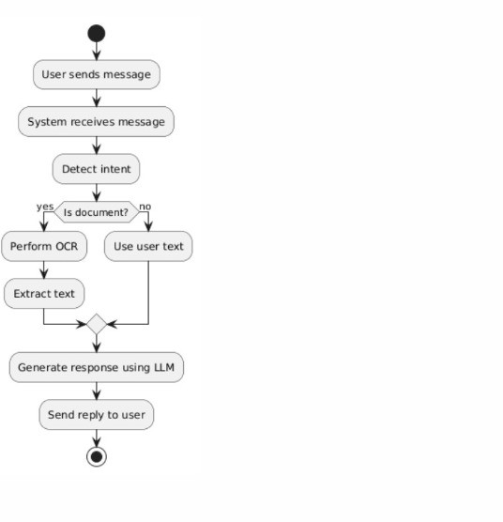

3. Sequence Diagram — Message Handling Flow

Overview
The sequence diagram models the runtime interaction between the user, the WhatsApp messaging gateway, the backend webhook (agent), and the Large Language Model (LLM). It shows the end-to-end flow for processing an incoming user message and returning an AI-generated reply via WhatsApp.

Actors / Lifelines

User: Initiates the conversation by sending a text, voice note or image from WhatsApp.

Twilio (Messaging Gateway): Receives the message from WhatsApp and forwards it to the application webhook. (Replace with Meta Business API if used.)

Webhook / Agent (Backend): Validates the webhook, orchestrates processing (intent detection, OCR/STT, LLM calls), and formats the reply.

LLM (AI Service): Receives prompts and context, performs inference, and returns structured responses for the agent to render.

Primary Message Flow (step-by-step)

Send message (User → Twilio): The user sends a message on WhatsApp; Twilio accepts and acknowledges the message on the WhatsApp channel.

Forward message (Twilio → Webhook): Twilio posts the message payload to the application webhook endpoint. The webhook authenticates the request and queues processing.

handle_message() (Webhook → Agent): The webhook invokes the agent logic to process the incoming message. The agent determines message type (text / voice / image) and intent.

(Optional) Preprocessing: If the input is a voice note, an STT service converts it to text; if it is an image (prescription/report), the agent enqueues OCR preprocessing and extraction. These tasks may run asynchronously.

generate_response(message) (Agent → LLM): The agent constructs a prompt that includes user text, recent session context, and any OCR/STT output, then calls the LLM via OpenRouter or another API.

response (LLM → Agent): The LLM returns a constrained, often JSON- formatted response (possible conditions, recommended next steps, or order instructions). The agent validates and post-processes this output (adds
disclaimers, checks for high-risk flags).formatted reply (Agent → Webhook): The agent transforms the LLM output into user- facing text or template messages suitable for WhatsApp (including buttons or quick replies if supported).

send reply (Webhook → Twilio): The webhook issues a send-message request to Twilio with the formatted content. For proactive messages (reminders), approved templates are used.

deliver reply (Twilio → User): Twilio delivers the message back to the user’s WhatsApp client. Interaction terminates until the next user input.

Implementation & Operational Notes

Asynchronous processing: OCR, STT and long-running LLM calls should be executed by background workers (e.g., Celery) to keep webhook response times low and acknowledge receipts quickly.

Error handling & fallbacks: If OCR/STT confidence is low or the LLM returns ambiguous text, the agent should prompt the user for clarification or offer to escalate to a human reviewer. Implement retries and circuit-breakers for third-party APIs.

Security & compliance: Webhook authentication, TLS for all API calls, encryption of stored media, and logging of consent flags are mandatory to satisfy data-protection requirements (DPDP / GDPR / HIPAA as applicable).

Message templates & quotas: Proactive reminders must use pre-approved WhatsApp templates; be mindful of messaging quotas for trial/paid Twilio accounts and design reminder flows accordingly.

Sequence Diagram — Message Handling Flow
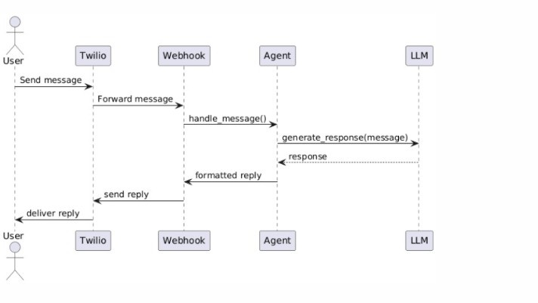

3.4.5 Languages Used:-

- Python is used for developing the backend of the healthcare chatbot, including WhatsApp webhook handling, OCR processing, LLM-based symptom analysis, API integration, and overall server-side logic. Its rich ecosystem of libraries (FastAPI/Flask, EasyOCR, Requests, OpenRouter API SDK) makes Python ideal for implementing AI-driven workflows and automation.

- JavaScript / ReactJS is used to create an optional web-based admin interface where system administrators can manage logs, view OCR outputs, update datasets, and monitor chatbot performance. React's component-based structure ensures scalability and ease of maintenance.

- SQL (PostgreSQL) is used to manage all structured data, including user information, conversation history, extracted medical values, prescription data, and order tracking details. SQL ensures data consistency, relational integrity, and secure storage for sensitive healthcare records.

- HTML & CSS are used to design and structure the web admin dashboard, ensuring a clean, responsive, and user-friendly interface for system monitoring and management.

Chapter 4

Conclusion:
The development of the AI-driven Healthcare Assistant demonstrates how modern technologies such as Large Language Models, OCR, and conversational interfaces can be combined to create an accessible and intelligent health-support system. By integrating WhatsApp as the primary communication channel, the project effectively bridges the gap between advanced AI capabilities and everyday user convenience, ensuring that individuals can receive preliminary medical guidance without the need for specialized applications or technical knowledge. This approach significantly enhances healthcare reach, especially for users in remote regions or those with limited digital literacy.

Through its multimodal processing abilities—text, voice, and document analysis—the system provides a unified platform capable of analyzing symptoms, interpreting prescriptions and lab reports, offering medicine- ordering support, and generating timely reminders. The backend architecture, built with Python, OCR pipelines, LLM reasoning, and secure database management, ensures reliable performance while maintaining data integrity and user privacy. These features together illustrate the potential of AI-powered tools to reduce the burden on healthcare infrastructure and improve the user experience in early-stage medical assessment.

While the system does not replace professional diagnosis, it serves as a valuable first-level assistant that empowers users with information, increases awareness, and guides them in taking appropriate next steps. The project highlights the importance of responsible AI use, implementing safety measures, disclaimers, and compliance with data-protection regulations. Overall, this work demonstrates a practical and scalable model for delivering AI-enabled healthcare support, paving the way for future enhancements such as telemedicine integration, multilingual voice intelligence, and more advanced medical data analysis.

References:

- Vaswani, A., Shazeer, N., Parmar, N., et al., “Attention Is All You Need,” Advances in Neural Information Processing Systems, 2017.

- Hugging Face, “Transformers: State-of-the-art Natural Language Processing for Pytorch and TensorFlow 2.0,” [Online]. Available: https://huggingface.co/transformers

- Devlin, J., Chang, M.-W., Lee, K., & Toutanova, K., “BERT: Pre-training of Deep Bidirectional Transformers for Language Understanding,” NAACL 2019.

- Alsentzer, E., Murphy, J., Boag, W., et al., “Publicly Available Clinical BERT Embeddings,”
NAACL 2019 Workshop on Biomedical NLP.

- OpenCV, “Open Source Computer Vision Library,” [Online]. Available: https://opencv.org

- Whisper,“OpenA Whisper:Automatic Speech Recognition,” [Online]. Available:
https://openai.com/research/whisper

- AWS Documentation,“Amazon Web Services Overview,” [Online].Available:
https://aws.amazon.com/documentation

- Flask, “Flask Web Framework Documentation,”[Online]. Available:
https://flask.palletsprojects.com

- FastAPI, “FastAPI: Modern, Fast (high-performance), web framework for building APIs with Python,” [Online]. Available: https://fastapi.tiangolo.com

- LangDetect, “Language Detection Library in Python,” [Online]. Available:
https://pypi.org/project/langdetect/

- gTTS, “Google Text-to-Speech Python Library,” [Online]. Available:
https://pypi.org/project/gTTS/

- Clinical NLP Papers, “Applications of NLP in Healthcare,” Journal of Biomedical Informatics, 2020.

